Assigement 1

1). What is an Arduino? Enlist advantages of Arduino and IDEs available used for Arduino Programming.

➢ Arduino is an open-source electronics platform based on easy-to-use hardware and software. Arduino boards are able to read inputs - light on a sensor, a finger on a button, or a Twitter message - and turn it into an output - activating a motor, turning on an LED, publishing something online.

• inexpensive.

• open source in hardware.

• don't need to external programmer (Burner)

• programming ease.

• open source in software.

2). What do you mean by development board? Enlist Arduino boards and Arduino shields available in market.

➢ A development board is a printed circuit board with circuitry and hardware designed to facilitate experimentation with a certain microcontroller. ... Also there are certain hardware circuits which greatly aid testing and debugging such as pushbuttons and LEDs

• Nano, Micro, Due, Lilypad, Mega, Leonardo, Zero boards by Arduino. Reboard Arduino Board spark fun.

3)

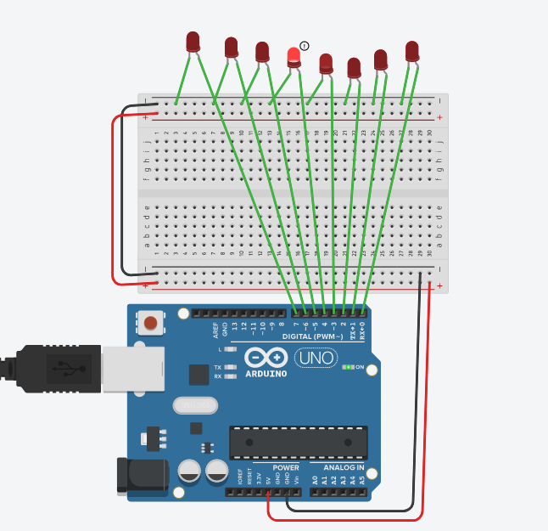

void setup()

{

pinMode(0, OUTPUT);

pinMode(1, OUTPUT);

pinMode(2, OUTPUT);

pinMode(3, OUTPUT);

pinMode(4, OUTPUT);

pinMode(5, OUTPUT);

pinMode(6, OUTPUT);

pinMode(7, OUTPUT);

}

int x = 500;

void loop()

{

digitalWrite(0, HIGH);

delay(x); // Wait for 1000 millisecond(s)

digitalWrite(0, LOW);

//delay(x); // Wait for 1000 millisecond(s)

digitalWrite(1, HIGH);

delay(x); // Wait for 1000 millisecond(s)

digitalWrite(1, LOW);

//delay(x); // Wait for 1000 millisecond(s)

digitalWrite(2, HIGH);

delay(x); // Wait for 1000 millisecond(s)

digitalWrite(2, LOW);

digitalWrite(3, HIGH);

delay(x); // Wait for 1000 millisecond(s)

digitalWrite(3, LOW);

digitalWrite(4, HIGH);

delay(x); // Wait for 1000 millisecond(s)

digitalWrite(4, LOW);

digitalWrite(5, HIGH);

delay(x); // Wait for 1000 millisecond(s)

digitalWrite(5, LOW);

//delay(x); // Wait for 1000 millisecond(s)

digitalWrite(6, HIGH);

delay(x); // Wait for 1000 millisecond(s)

digitalWrite(6, LOW);

digitalWrite(7, HIGH);

delay(x); // Wait for 1000 millisecond(s)

digitalWrite(7, LOW);

digitalWrite(8, HIGH);

delay(x); // Wait for 1000 millisecond(s)

digitalWrite(8, LOW);

digitalWrite(8, HIGH);

delay(x); // Wait for 1000 millisecond(s)

digitalWrite(8, LOW);

//delay(x); // Wait for 1000 millisecond(s)

digitalWrite(7, HIGH);

delay(x); // Wait for 1000 millisecond(s)

digitalWrite(7, LOW);

//delay(x); // Wait for 1000 millisecond(s)

digitalWrite(6, HIGH);

delay(x); // Wait for 1000 millisecond(s)

digitalWrite(6, LOW);

digitalWrite(5, HIGH);

delay(x); // Wait for 1000 millisecond(s)

digitalWrite(5, LOW);

digitalWrite(4, HIGH);

delay(x); // Wait for 1000 millisecond(s)

digitalWrite(4, LOW);

digitalWrite(3, HIGH);

delay(x); // Wait for 1000 millisecond(s)

digitalWrite(3, LOW);

//delay(x); // Wait for 1000 millisecond(s)

digitalWrite(2, HIGH);

delay(x); // Wait for 1000 millisecond(s)

digitalWrite(2, LOW);

digitalWrite(1, HIGH);

delay(x); // Wait for 1000 millisecond(s)

digitalWrite(1, LOW);

digitalWrite(0, HIGH);

delay(x); // Wait for 1000 millisecond(s)

digitalWrite(0, LOW);

}

4)

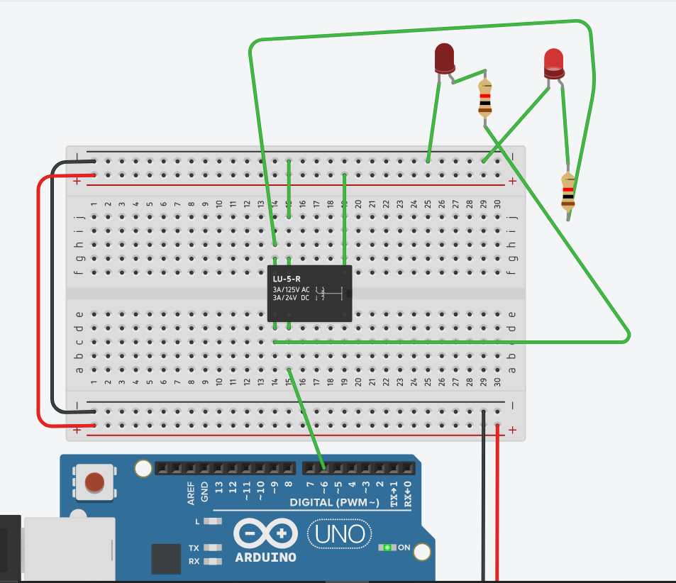

void setup()

{

pinMode(6, OUTPUT);

}

int x = 3000;

void loop()

{

digitalWrite(6, HIGH);

delay(x); // Wait for 1000 millisecond(s)

digitalWrite(6, LOW);

delay(x);

}

**5.** Interface DC motor and Buzzer with Arduino. Develop an Arduino sketch to rotate motor anti-clockwise for 10 seconds after that sound buzzer for 2 seconds and silent at last.

**Code:**

bool isOn = true;

void setup()

{

pinMode(8, OUTPUT);

pinMode(9, OUTPUT);

}

void loop()

{

if(isOn){

digitalWrite(9, HIGH);

delay(10000);

digitalWrite(9, LOW);

digitalWrite(8, HIGH);

delay(2000);

digitalWrite(8, LOW);

isOn = false;

}

}

**Circuit:**

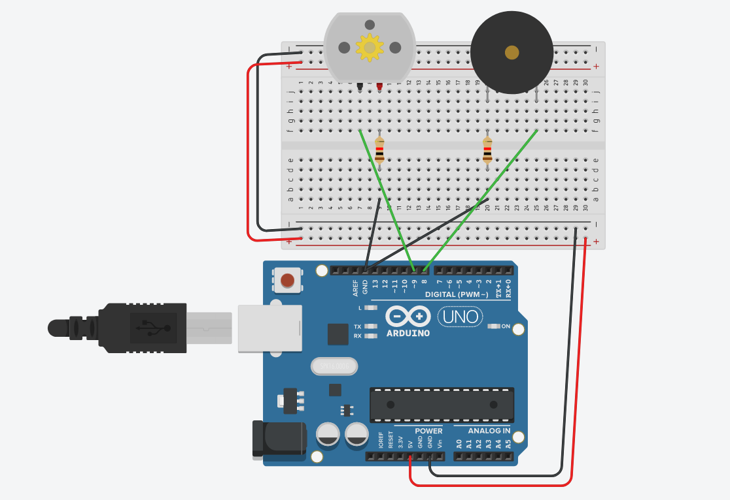

**6**. Interface seven segment LED display with Arduino. Write a program display first ODD numbers and then EVEN numbers on seven segment with delay of 1 second (the numbers are in between 0 to 9).

|  |  |
| --- | --- |
| Arduino Pin | 7- Segment Pin |
| Digital 3 | A |
| Digital 2 | B |
| Digital 11 | C |
| Digital 6 | D |
| Digital 7 | E |
| Digital 4 | G |
| Digital 10 | H |
| Digital 9 | F |

**Code:**

int pins_used[] = {2,3,4,6,7,9,10,11};

byte digit[][2] =

{

// EDxGABxx xxCHFx

{0b11001100, 0b001010}, //0

{0b00000100, 0b001000}, //1

{0b11011100, 0b000000}, //2

{0b01011100, 0b001000}, //3

{0b00010100, 0b001010}, //4

{0b01011000, 0b001010}, //5

{0b11011000, 0b001010}, //6

{0b00001100, 0b001010}, //7

{0b11011100, 0b001010}, //8

{0b01011100, 0b001010} //9

};

void setup() {

// put your setup code here, to run once:

for(auto pin : pins_used) pinMode( pin, OUTPUT );

}

void display(int i){

PORTD = digit[ i ][0];

PORTB = digit[ i ][1];

}

void loop() {

//ODD

for(int i = 1; i <= 9; i+=2){

display(i);

delay( 1000 );

}

delay(1000);

//EVEN

for(int i = 0; i <= 9; i+=2){

display(i);

delay(1000);

}

}

**Circuit:**

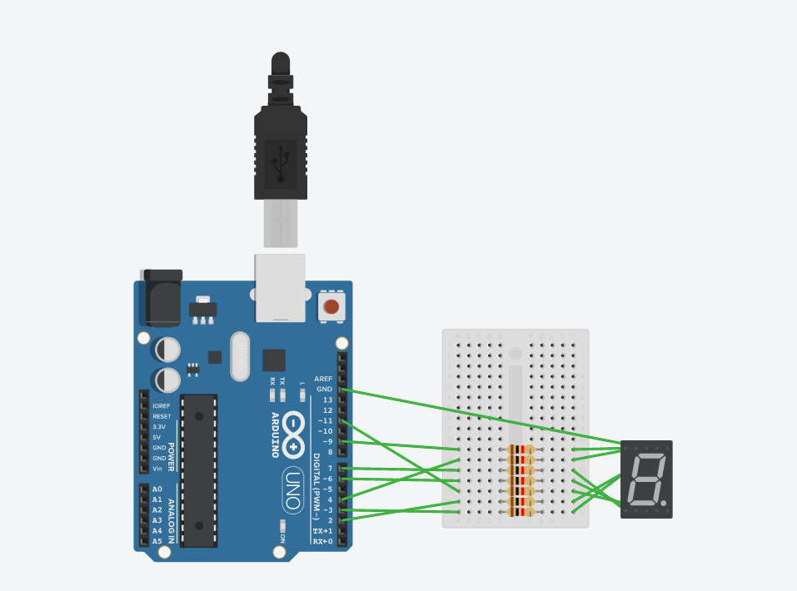

**Day – 2 Assignment**

**LED Interfacing & Serial Communication**

1. Write program to display 1 to 100 on LCD.

**Code:**

#include <LiquidCrystal.h>

LiquidCrystal lcd(12,11,10,9,8,7,6);

//LiquidCrystal(rs,rw,enable, d4, d5, d6, d7)

void setup()

{

lcd.begin(16,2);

}

void loop() {

int i =1;

for(i=1;i<101;i++){

lcd.setCursor(5,0);

lcd.print("Number");

lcd.setCursor(7,1);

lcd.print(i);

delay(500);

lcd.clear();

}

}

**Circuit:**

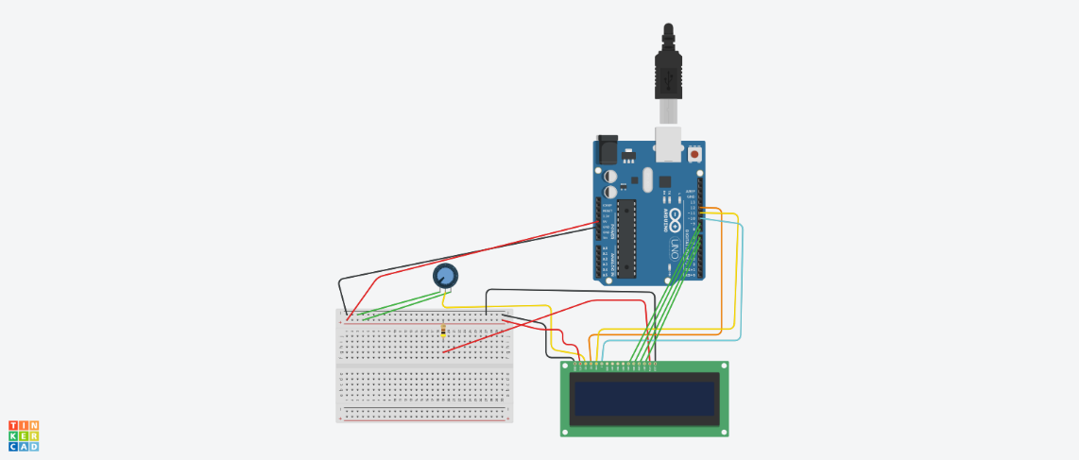

1. Write your name on LCD scroll left and scroll right.

**Code:**

#include <LiquidCrystal.h>

LiquidCrystal lcd(12,11,10,9,8,7,6);

//LiquidCrystal(rs,rw,enable, d4, d5, d6, d7)

void setup()

{

lcd.begin(16,2);

}

void loop() {

lcd.setCursor(1,0);

lcd.print("ARYANT PATEL");

//lcd.scrollDisplayLeft();

//delay(10);

lcd.scrollDisplayRight();

delay(10);

}

**Circuit:**

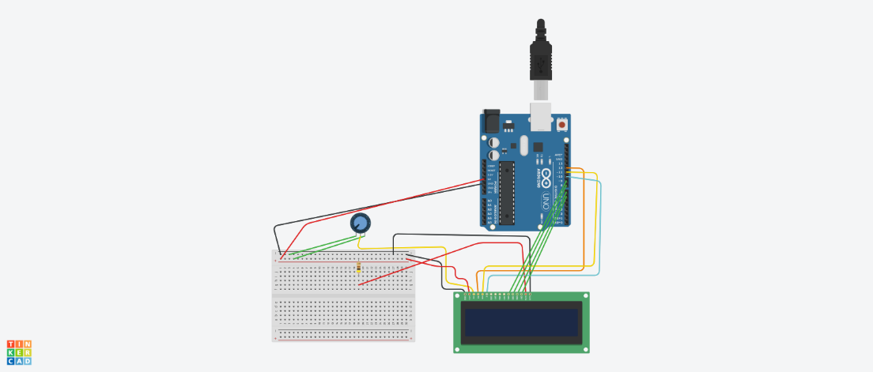

1. Write program to show clock on LCD as follows.

**Code:**

#include <LiquidCrystal.h>

LiquidCrystal lcd(12,11,10,9,8,7,6);

//LiquidCrystal(rs,rw,enable, d4, d5, d6, d7)

void setup()

{

lcd.begin(16,2);

}

void loop() {

lcd.setCursor(3,0);

lcd.print("Time");

lcd.setCursor(1,1);

lcd.print("01:25:34");

delay(10);

}

**Circuit:**

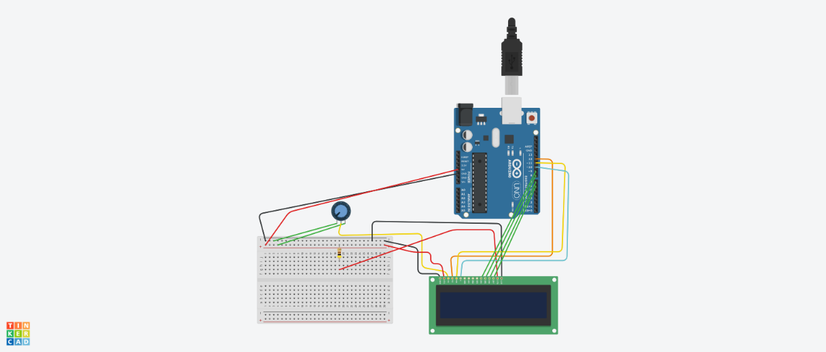

1. Display the string on LCD Ex.; “Hello World”.

**Code:**

#include <LiquidCrystal.h>

LiquidCrystal lcd(12,11,10,9,8,7,6);

//LiquidCrystal(rs,rw,enable, d4, d5, d6, d7)

void setup()

{

lcd.begin(16,2);

lcd.print("Hello World");

}

void loop() {

}

**Circuit:**



1. Interface 4 push button & do following:

** SW1 : when press, display 0 to 9 on LCD

** SW2 : when press, display 00 to 99 on LCD

** SW3 : when press, display 000 to 999 on LCD

** SW4 : when press, display 0000 to 9999 on LCD

**Code:**

#include <LiquidCrystal.h>

LiquidCrystal lcd(12,11,10,9,8,7,6);

//LiquidCrystal(rs,rw,enable, d4, d5, d6, d7)

void setup()

{

lcd.begin(16,2);

Serial.begin(9600);

pinMode(2,INPUT);

pinMode(3,INPUT);

pinMode(4,INPUT);

pinMode(5,INPUT);

}

void loop() {

int i=0;

int x = digitalRead(2);

int y = digitalRead(3);

int z = digitalRead(4);

int w = digitalRead(5);

//Serial.print("x:");

//Serial.println(x);

//Serial.print("y:");

//Serial.println(y);

//Serial.print("z:");

//Serial.println(z);

//Serial.print("w:");

//Serial.println(w);

if(x == 1){

for(i=0;i<=9;i++){

lcd.setCursor(6,0);

lcd.print(i);

delay(1000);

lcd.clear();

}

}

if(y == 1){

for(i=0;i<=9;i++){

lcd.setCursor(6,0);

lcd.print(i);

lcd.setCursor(7,0);

lcd.print(i);

delay(1000);

lcd.clear();

}

}

if(z == 1){

for(i=0;i<=9;i++){

lcd.setCursor(5,0);

lcd.print(i);

lcd.setCursor(6,0);

lcd.print(i);

lcd.setCursor(7,0);

lcd.print(i);

delay(1000);

lcd.clear();

}

}

if(w == 1){

for(i=0;i<=9;i++){

lcd.setCursor(5,0);

lcd.print(i);

lcd.setCursor(6,0);

lcd.print(i);

lcd.setCursor(7,0);

lcd.print(i);

lcd.setCursor(8,0);

lcd.print(i);

delay(1000);

lcd.clear();

}

}

}

**Circuit:**

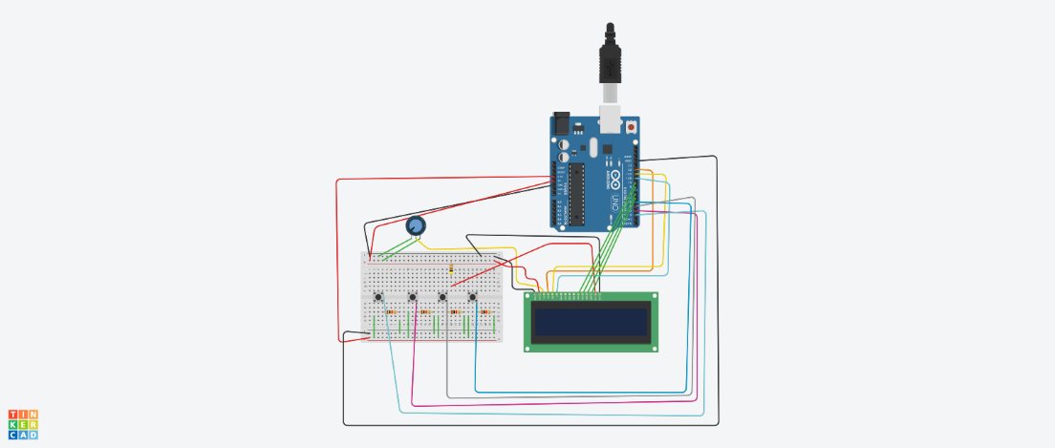

1. Set the time using four switch and display the clock on LCD

** SW1 : when press, increment 1 digit

** SW2 : when press, decrement 1 digit

** SW3 : when press, display set time and start the clock

** SW4 : when press, reset the clock

**Code:**

#include <LiquidCrystal.h>

LiquidCrystal lcd(12,11,10,9,8,7,6);

//LiquidCrystal(rs,rw,enable, d4, d5, d6, d7)

void setup()

{

lcd.begin(16,2);

Serial.begin(9600);

pinMode(2,INPUT);

pinMode(3,INPUT);

pinMode(4,INPUT);

pinMode(5,INPUT);

}

int i=0;

void loop() {

int x = digitalRead(2);

int y = digitalRead(3);

int z = digitalRead(4);

int w = digitalRead(5);

//Serial.print("x:");

//Serial.println(x);

//Serial.print("y:");

//Serial.println(y);

//Serial.print("z:");

//Serial.println(z);

//Serial.print("w:");

//Serial.println(w);

if(x == 1){

lcd.setCursor(0,0);

i++;

lcd.print(i);

}

if(y == 1){

lcd.setCursor(0,0);

if(i>0){

i--;

}

lcd.print(i);

}

if(z == 1){

lcd.setCursor(0,0);

lcd.print(i);

}

if(w == 1){

lcd.clear();

}

}

**Circuit:**



1. Receive serially data 0 to 9 and display on LCD.

**Code:**

#include <LiquidCrystal.h>

LiquidCrystal lcd(12,11,10,9,8,7,6);

//LiquidCrystal(rs,rw,enable, d4, d5, d6, d7)

void setup()

{

lcd.begin(16,2);

Serial.begin(9600);

}

void loop() {

char x;

Serial.println("Enter Data");

if(Serial.available()>0)

{

x = (char)Serial.read();

Serial.println(x);

lcd.print(x);

}

delay(1000);

lcd.clear();

}

**Circuit:**

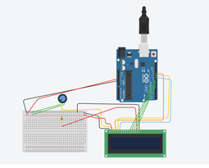

1. Transmit “Hello World!” serially and display on monitor.

**Code:**

#include <LiquidCrystal.h>

LiquidCrystal lcd(12,11,10,9,8,7,6);

//LiquidCrystal(rs,rw,enable, d4, d5, d6, d7)

int i=1;

void setup()

{

lcd.begin(16,2);

Serial.begin(9600);

}

void loop() {

lcd.setCursor(i,0);

char x;

Serial.println("Enter Data");

if(Serial.available()>0)

{

x = (char)Serial.read();

Serial.println(x);

lcd.print(x);

i++;

lcd.setCursor(i,0);

}

delay(1000);

}

**Circuit:**



1. Transmit “Hello World!” serially and display on monitor.

**Code:**

void setup() {

Serial.begin(9600);

Serial.print("Enter data");

}

void loop() {

char ch;

ch = Serial.read();

delay(1000);

Serial.println(ch);

}

**Circuit:**

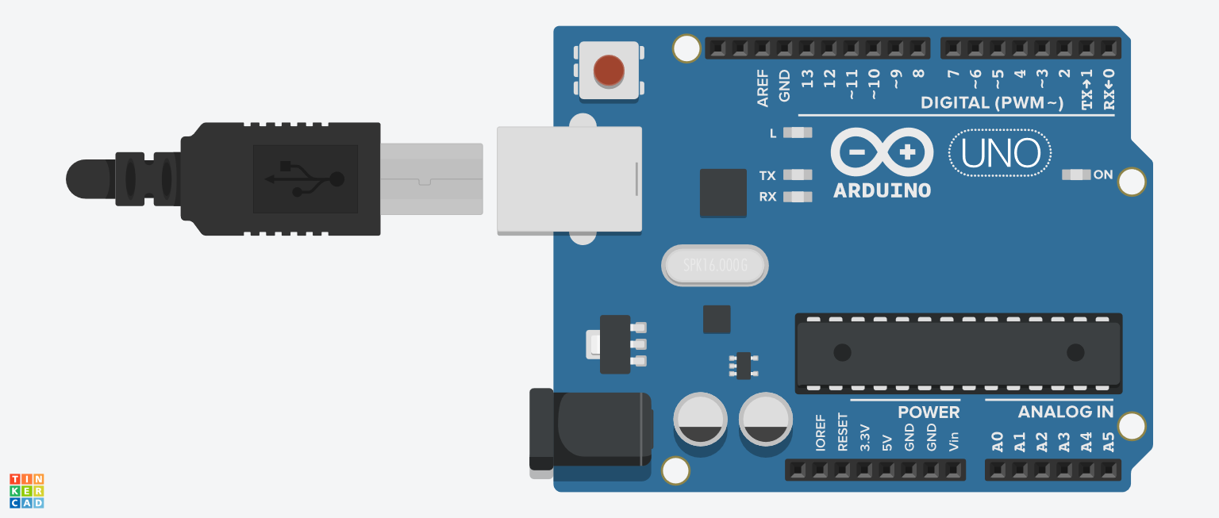

1. Interface switch and do following:

** SW1: when press, transmit “Good Morning”

** SW2: when open, transmit “Bad Morning”

**Code:**

#include <LiquidCrystal.h>

LiquidCrystal lcd(12,11,10,9,8,7,6);

//LiquidCrystal(rs,rw,enable, d4, d5, d6, d7)

void setup()

{

lcd.begin(16,2);

Serial.begin(9600);

pinMode(3,INPUT);

pinMode(4,INPUT);

}

void loop() {

int i=0;

int x = digitalRead(3);

int y = digitalRead(4);

if(x == 1){

lcd.print("Good Morning!");

delay(4000);

lcd.clear();

}

if(y == 1){

lcd.print("Bad Morning!");

delay(4000);

lcd.clear();

}

}

**Circuit:**

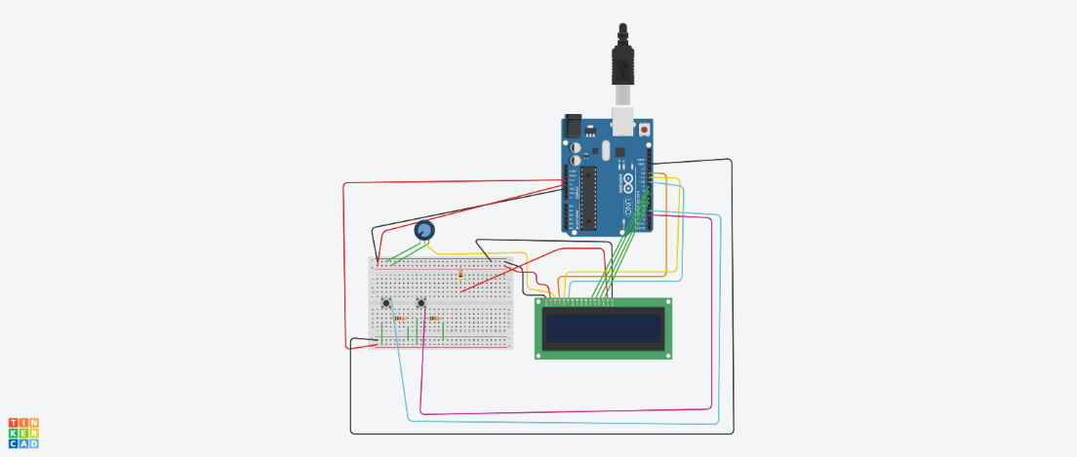

1. Connect switch to Arduino. If switch is on than print ”ON” else print “OFF” on serial monitor

**Code:**

void setup() {

Serial.begin(9600);

pinMode(13,INPUT);

}

void loop() {

int x = digitalRead(13);

if(x == HIGH){

Serial.println("ON");

}

else if (x == LOW){

Serial.println("OFF");

}

}

**Circuit:**

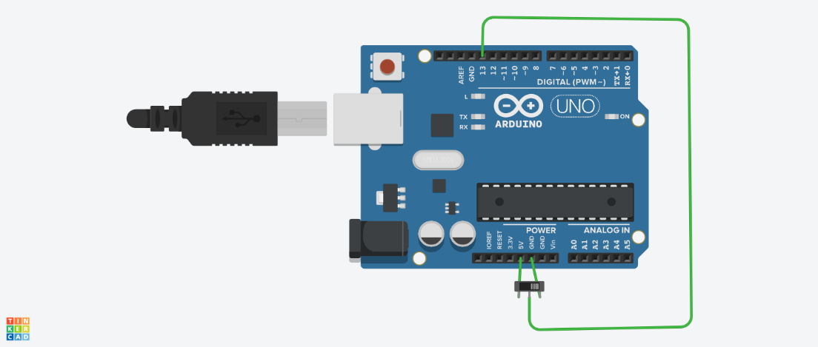

**Day – 3 Assignment**

**1.** Interface temperature sensor, LCD and buzzer with Arduino UNO. Develop an Arduino sketch do follows:

Display temperature on the LCD.

If temperature is above 50 `C then sound the buzzer otherwise silent it.

**Code:**

#include <LiquidCrystal.h>

LiquidCrystal lcd(12,11,10,9,8,7,6);

//LiquidCrystal(rs,rw,enable, d4, d5, d6, d7)

void setup()

{

Serial.begin(9600);

lcd.begin(16,2);

lcd.print("temp =");

pinMode(3,OUTPUT);

}

void loop() {

float vin = analogRead(A0);

float tempvc = (vin *5000)/1024;

float tempc = (tempvc/10) +(-50);

lcd.setCursor(8,0);

lcd.print(tempc);

if(tempc > 50){

digitalWrite(3,HIGH);

}

else{

digitalWrite(3,LOW);

}

}

**Circuit:**

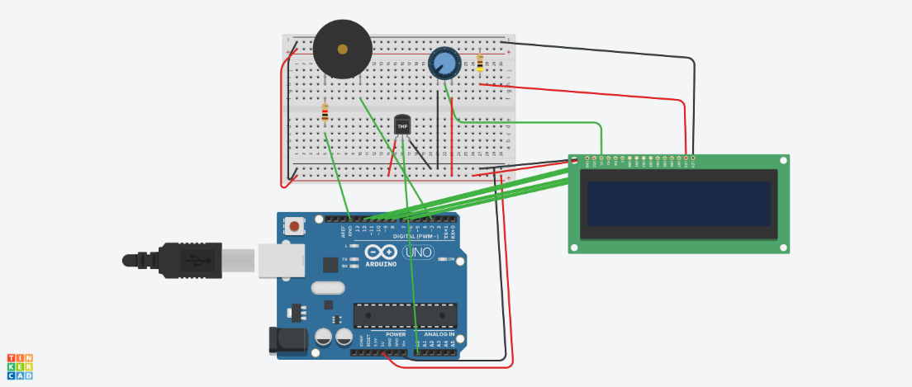

**2.** Interface Potentiometer and dc motor with Arduino Uno. Develop an Arduino sketch to control speed of DC motor using Potentiometer.

**Code:**

void setup()

{

pinMode(10, OUTPUT);

//pinMode(A1, OUTPUT);

Serial.begin(9600);

pinMode(A0,INPUT);

}

void loop()

{

int speed = analogRead(A0);

Serial.println(speed/4);

analogWrite(10,speed/4);

}

**Circuit:**

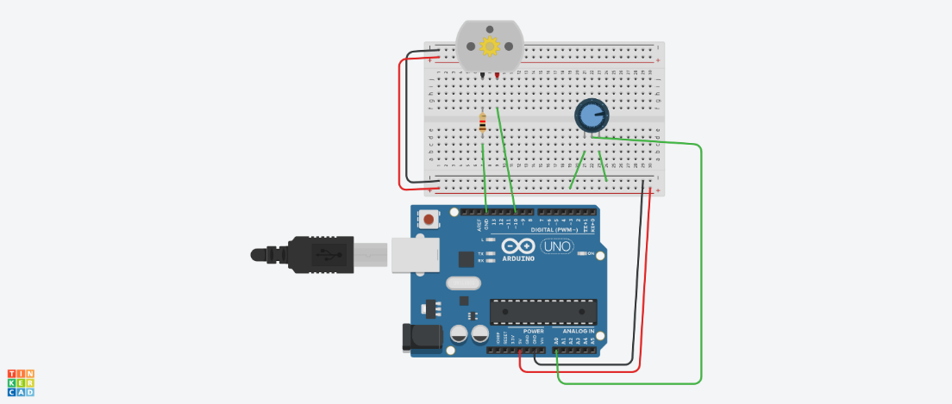

3. Interface Potentiometer and servo motor with Arduino Uno. Develop an Arduino sketch to control angle of servo motor using potentiometer.

**Code:**

#include <Servo.h>

Servo myservo;

void setup()

{

myservo.attach(10);

Serial.begin(9600);

pinMode(A0,INPUT);

}

void loop()

{

int value = analogRead(A0);

Serial.println(value/4);

myservo.write(value/4);

delay(15);

}

**Circuit:**

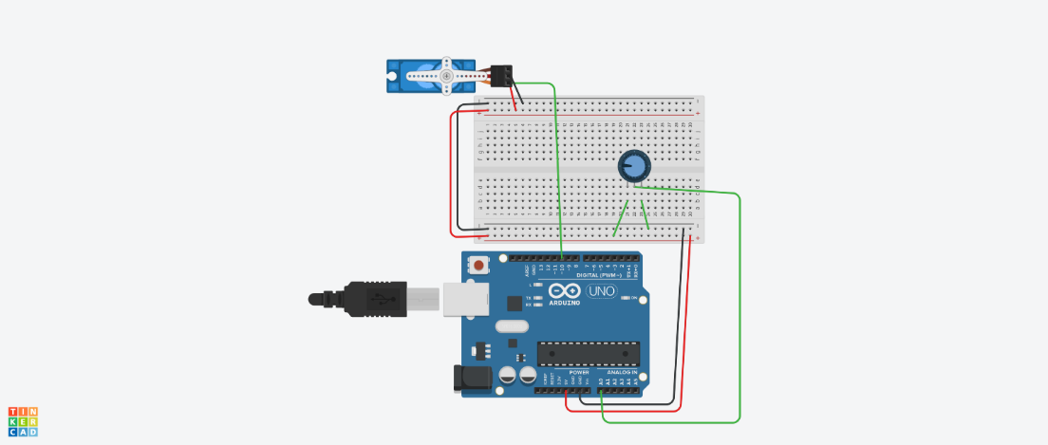

4. Identify bugs and resolve it to fulfil following objective. Interface 3 LEDs and 4 SWICHES with Arduino. Develop a program that by pressing 1st switch it will ON LED1, by pressing 2nd switch it ON LED2 and same for 3rd switch and LED3. By pressing 4th switch it will reset (OFF) all LEDs.

**Circuit:**



**Given Code:**

const int LED1 = 7;

const int LED2 = 6;

const int LED3 = 5;

const int LED4 = 8;

const int BUTTON1 = 2;

const int BUTTON2 = 3;

const int BUTTON3 = 0;

const int BUTTON4 = 1;

int Buttonmodel = 0;

int Buttonmode2 = 0;

int Buttonmode3 = 0;

int Buttonmode4 = 0;

void setup [] {

// put your setup code here, to run once:

pinMode(LeD1,INPUT);

pinMode(LEd2,input);

pinMode(LED1,INPUT);

pinMode(LED2,input)

pinMode(BUT0N1,INPUT_);

pinMode(BuT0N2,INPUT_);

pinMode(BUTON3,INPUT_);

pinMode(BUTON4,INPUT_);

}

void loop[] (

// put your main code here, to run repeatedly:

//First LED interface

Buttonmode1 == digitalread(BUTT0Nl);

if(Buttonmode1 = high)

{

digitalwrite(LED1,HIGH);

else

digitalWrite(LED1,HIGH);

}

//Second LED interface

Butonmode2 = digita1Read(BUTTON2);

if(Buttonmode2 = LoW)

{

digitalWrite(LED2,L0W);

}

else

digitalwrite(LEd2,HIGH);

}

//Third LED interface

Buttonmode3 = digitalread(BUTTON3);

if(Buttonmode3 = HIGH);

{

digitalWrite(LED3,LOW);

}

else

{

digitalwrite(LED3,HIGH)

}

//Fourth LED interface

Buttonm0de4 = digiatlRead(BUTTON4);

if(Buttonmode4 = LOW)

{

digitalWrite(LeD4,LOW)

}

else

{

digitalWrite(LED4,HIGH);

}

}

}

**Corrected Code:**

const int LED1 = 7;

const int LED2 = 6;

const int LED3 = 5;

const int BUTTON1 = 2;

const int BUTTON2 = 3;

const int BUTTON3 = 0;

const int BUTTON4 = 1;

int Buttonmodel = 0;

int Buttonmode2 = 0;

int Buttonmode3 = 0;

int Buttonmode4 = 0;

void setup () {

// put your setup code here, to run once:

pinMode(LED1,OUTPUT);

pinMode(LED2, OUTPUT);

pinMode(LED3, OUTPUT);

pinMode(BUTTON1,INPUT);

pinMode(BUTTON2,INPUT);

pinMode(BUTTON3,INPUT);

pinMode(BUTTON4,INPUT);

}

void loop(){

// put your main code here, to run repeatedly:

//First LED interface

Buttonmode1 == digitalRead(BUTTONl);

if(Buttonmode1 = HIGH)

{

digitalWrite(LED1,HIGH);

}

//Second LED interface

Butonmode2 = digita1Read (BUTTON2);

if(Buttonmode2 = HIGH)

{

digitalWrite(LED2,HIGH);

}

//Third LED interface

Buttonmode3 = digitalRead(BUTTON3);

if(Buttonmode3 = HIGH);

{

digitalWrite(LED3,HIGH);

}

//Fourth LED interface

Buttonmode4 = digitalRead(BUTTON4);

if(Buttonmode4 = HIGH)

{

digitalWrite(LED1,LOW);

digitalWrite(LED2,LOW);

digitalWrite(LED3,LOW);

}

}